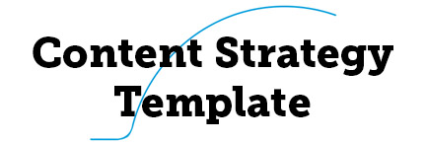

How you build your strategy will depend a lot upon what your client has asked for, the information you learn about the challenges they are facing, the industry you're working within, and the amount of time you are able to devote to the strategy.

This template has all the elements you'll need to start researching and writing a content strategy. It's also structured to help you tell a story with that strategy.

As a strategist, you'll find sections you want to omit and sections you want to expand. That's excellent. Because each strategy is unique to the situation, take what you can use and then make the template your own. Also, you won't see a lot of charts and tables in the examples; that's because we're working with a hypothetical client. Remember that data can help you sell your points, so don't forget to illustrate your strategy and include actual statistics when appropriate.

This template is broken down into the following sections:

- Introduction. This section gives you an idea of what kind of research you'll be doing to figure out where the content strategy starts.
- Prologue. Getting started with a core strategy.
- Chapter 1: Onsite Content. Applying your core strategy to this channel.
- Chapter 2: Blog. What you need to know to include a blog in your strategy.
- Chapter 3: Offsite Content. How your core strategy affects offsite channels
- Chapter 4: Governance. Creating the rules and docs that will help your strategy succeed.
- Chapter 5: Workflow. Make sure you have all the right players in all the right positions to efficiently implement your strategy.
- Epilogue. Where to start putting that strategy into action and how to measure success.

You'll notice that this template uses a storytelling framework where the brand is the hero and the strategy is the path the hero takes to achieve whatever goals you identify. I like to use this approach because it speaks to our innate love of story (so it helps people engage) and it also speaks to the journey a company is embarking on (which helps people envision the road ahead). Like everything else in this template, the storytelling style is optional and you should feel free to change it to suit your needs.



This is where you pull together all of your research to define a starting point for your content strategy. It's the discovery phase and the part of the strategy where you bring all of the underlying assumptions to the surface.

Once upon a time or in the beginning there was a brand. The brand either had some content that this story builds upon (in which case we'll use this section to describe and evaluate those assets) or the brand is newly created or starting over (in which case we'll describe and evaluate assets of other brands that are either related or we can learn from).

Contents
To set the stage and make sure that you and the decisions makers you are working with are on the same page, describe the following:

- Brand: How is the brand currently perceived? What are its specific value propositions? What is and is not going well with the brand's current content?
- Goals: Where does the brand want to get to? Start to think about how content can and cannot help achieve those goals. For example, if the brand wants to enter into the Chinese market and earn $10m in sales in the next year, content (in Chinese) can help the brand build affinity. Content cannot (directly) help you make sure that new distributor is delivering parts on time.
- Setting: Is the brand operating solely online or does it have physical locations? How does this affect content opportunities and execution? Evaluate the channels the brand is using and the channels it should be using. This is where you also describe the current audience and the target audience.
- Competitors: Who has the brand identified as competitors? Who do you see as competitors? Give a brief overview of what they are doing well and poorly.

Note that because the rest of your strategy is built from here, you might want to get buy-in on these starting assumptions before you get too invested in moving forward. Although you may be working in-house, it's sometimes helpful to think of the decision makers who will have final say on the implementation of your strategy as clients. This allows you to more easily see processes from the outside—so you can get a better picture of problems and opportunities.

Background research
To really understand where the company is starting from, your research could involve any of the following:

- Personas. Who is the target audience? What are their needs and what motivates them? If these don't exist, you might want to create some.
- Stakeholder interviews. These interviews can tell you about everything from internal processes and roadblocks to questions customers have but have been afraid to ask. Dig deep and keep asking "why?" to get the best information.
- Content inventory. This is a quantitative assessment of the content you already have. Where does content live right now? How much is there? Gather data on the URLs, metadata, links, author, date last updated, target keywords, etc.
- Content audit. Use this qualitative assessment as an opportunity to evaluate everything you found in the content inventory. Is the content good? Is it accessible and on-brand? Does it meet the needs of the audience? What gets the most (and least) traffic? How does the bounce rate and time on page look? Are the social shares strong or weak? If it's content that's meant to convert, is it converting? See what kinds of trends emerge about content that performs well and poorly.
- Gap analysis. Now look for where content is missing. Are there types of pages that should have content but don't? And are there topics that should be covered and aren't?
- Competitive analysis. Now go back and do as much of the above as you can for the brand's competitors.

Tools
There are a lot of great tools available, so consider this list just a starting point:

- Analytics. Google Analytics and Moz Analytics can help you identify top landing pages and focus your efforts in the places that see the most traffic.
- Inventories. Screaming Frog helps you download a list of all your URLs.
- Audits. The Content Analysis Tool and Open Site Explorer show you different measures of content success.
- Surveys. Use Google Consumer Surveys to reach beyond your normal audience. Qualaroo lets you poll your visitors while they are on your site with a popup window.
- Heat and scroll maps. CrazyEgg shows you where visitors are clicking and how far down the page they're actually scrolling.

Brand
Brand X started out as a well-respected cloud storage service. Your services are more secure than most competitors and as a result your current customer base is mostly mid-level investment firms who love the security. Recently, you've been excited to invest even more in the business and find a niche, so you've invested in a fantastically well-designed user interface.

Goals
As you upgraded your UI, you've been realizing that there's a niche audience of people who might appreciate the attention to detail: indie game developers. They're hip to the latest web technologies and also care deeply about aesthetics. They use a good deal of cloud space, so they need you, and they're also cool enough to serve as brand ambassadors. You want to create content that will attract this audience.

In addition, we'd like to see more visitors either end their journey at your contact page (customers who are ready to convert) or increase the number of pages visitors visit before leaving your site (people who are not ready to convert but with whom you can build trust over time).

Setting
Right now your content is still in the "safe and secure" category—nothing (beyond your interface) shows off the personality you want to be recognized for. You are using a lot of stock imagery that also lacks personality. While Brand X currently has a blog, you're mostly using it to promote press releases. A couple of articles, notably "13 Steps to Ensure Your Clients' Data is Secure," have done well on LinkedIn, but the brand is getting very little traction on Reddit, Twitter, and Google+.

Currently, the pages that get the most traffic are the home page, about page, and the privacy page. This indicates that the current audience is vetting the company's reputation before engaging your services. A lot of that traffic bounces off your site before ever reaching your contact page.

You have a solid set of FAQs for businesses that are starting to use the cloud, but very little information for businesses migrating between cloud providers. Also, we think a drip campaign might be useful to reach visitors who want to learn more about how they can leverage the cloud to improve their business.

Competitors
You're in a crowded field, but also one where many businesses are taking a transactional approach to their relationships. Brand Y has a particularly strong series of infographics explaining how the cloud works, but these are targeted at mommy bloggers. Meanwhile, Brand Z has a simple and effective guide to finding the level of cloud storage that's right for a particular business. Brand F uses very little copy on their site, but their email newsletters are remarkably fun to read.

We could not find anyone who is targeting exactly the audience that you are, which means you have a lot of opportunity to expand and make the space your own.



Now that you understand the environment that your content strategy will be building on, it's time to start the story itself.

This section of the strategy is where you set the stage and can serve as an executive summary of the overall strategy.

The prologue is where you lay the foundation. This section should include:

- Core strategy. Distill the strategy down to a sentence that is both memorable and overarching. This core strategy is the heart of what the company wants to do and this sentence will be the grounding point that stakeholders can return to when questions arise.
- Themes and messages. Describe the central themes and messages that content should express. You don't have to break them down by channel; that will come later.
- Content plan. Sketch out the broad strokes of the plan including what channels will be used. Also hint at any major recommendations you'll be making, whether it's building a new CMS or making large changes to the workflow.

Core Strategy
Brand X will empower game developers and other creatives by providing the cloud space they need and the resources they can use to build projects that surpass even their imaginations.

Themes
To reach that new audience and continue to serve your existing audience, Brand X should concentrate on the following themes:

- Technology. Starting with the cloud and expanding into other areas that might fulfill your core strategy, bring your audience the news and tools they can use to make amazing things. This could be anything from an article on how to make do with less memory to how low-poly assets can enhance game play.
- Creativity. Everyone needs a little inspiration sometimes. Reach that creative audience by finding what inspires them and what they need when they're feeling uninspired. You could do anything from creating mood boards for specific types of online games to building a slot machine-inspired interactive that asks visitors to create a story from three randomly selected images.
- Business (for creatives). Rare is the person who is wildly creative and also a business maven. Help your customers get a leg up on success by becoming a resource for business info that's accessible to creative thinkers like "Tax Write-Offs Only Photographers Can Take."

Not all content will cover all themes—in fact it shouldn't, because sometimes you need to specialize in order to make the best possible work.

A note about content and risk: Ian Lurie of Portent, Inc. often refers to something called the 70/20/10 rule. This is the ratio of your content that you want to be safe, moderately risky, and very risky. You need the 70% content—your FAQs and pricing page are examples—because your customers need that information. The 20%—e.g. articles about creativity—is content that visitors might want to share. It's riskier and sometimes reaches beyond your business model, but it should always be related to your core strategy. The 10%—like the slot machine interactive—should be risky enough that it scares you a little. It might fail, but if it succeeds, the payoff is worth all the effort.

Content Plan
For this campaign, we'll be looking at integrating the core strategy into your onsite content, blog, and offsite content. You'll find a chapter devoted to each below.

We want to get you started on the right foot by giving you the information you need to develop brand guidelines and a voice and style guide. In addition, we'll be proposing a few steps to streamline your content workflow and develop a content lifecycle.



Onsite content is just that: content that lives on your site. Examples include: homepage and landing page text, error messages, button text, FAQs, videos, whitepapers, product descriptions, pricing information, and contact details. While blog content is technically also onsite content, it presents enough unique opportunities and challenges that we've given blogs a separate chapter.

This chapter of the content strategy is your chance to take all that research you did at the outset. Distill that into observations about existing onsite content and then provide recommendations about how site content can be improved.
We mentioned earlier that your existing onsite content is safe. Too safe. Even your 70% content is dry and bordering on boring. This was really effective to get you where you are, which is good. Now you're ready for the next stage. Here's how to change up your content to match your shiny new look (and capture that creative market in the process):

- Tone. We'll be discussing brand, voice, and style guidelines in Chapter 4, but know that revisiting your existing content with an eye to adhering to those new guidelines should be a priority.
- Imagery. Get ready to take some chances with your images. If possible, invest in a staff member with a background in photography. Your best bet is to replace all your stock photos with custom images that capture your creative spirit. It will take some time, but it's worth it.
- Error messages. You're currently returning a generic error message when a page is down. Don't miss this opportunity to do something cheeky and keep people entertained rather than encouraging them to bounce.
- Contact page. Right now you just have an anonymous email address. Flesh this out so your visitors know who they are contacting and why. Suggest a use case like, "having technical difficulties?" or "need an billing question answered?" and then give them a specific person with a name and a picture that they can talk to. Your audience is still small enough that this personal touch is viable. Don't overwhelm them with options, though; no more than three should be presented.
- FAQs. Start to expand the business cases you're addressing with these. You will have some customers who are new to the cloud, but it's time to add support for others. Think about your customers' needs. You might end up with enough information that you want to subdivide the FAQs into information for newbies and cloud veterans, but that division would be premature at this time. Keep an eye on it.
- Keep visitors on page. Your new design is very clean. Almost to a fault. Visitors are given the option to get a little more information, convert, or bounce. Surface the blog in your main nav so visitors who still want to get to know you know where to go.
- Expand your content types. There are a few places you could add interesting content including the account setup page and the troubleshooting page. Try adding screencasts or videos to these pages—they'll actually be more helpful.

Remember as you create all of this content that you're trying to capture that new audience, so use that style guide.



Notice something missing from the last chapter? The blog. It's all most people think of when they think of content, especially onsite content. And it's definitely where you get to show off your content. The blog is also a good place to start sprinkling in your 20% content (and even some 10% if it fits).

Many companies use their blogs as a PR vehicle, but you already know that no one wants to read press releases, right? If a blog is the right answer for the company you're investigating (and there are times when it isn't), always keep the audience's needs in mind. You've already identified themes by now. The blog is where you can tweak those themes into categories and let that content team loose.
Your blog has been around for two years, but you're not getting any social shares and you've never had someone comment. This is because you're using it solely as a megaphone to tell others how amazing your company is. The trouble is that no one wants to hear about a company, especially not one that does something they may or may not be able to explain at the dinner table. They want to hear about themselves—about things that directly impact their lives. They want to hear and read and watch content that offers solutions and inspiration and other things that feel tailor-made for them.

To make that switch, it's time to rework your categories, and we'll be using those themes we identified earlier as a starting point. Your new categories should be:

- What tech can do for you. This category highlights technology solutions for creatives. It could include an article on capitalizing on the space-saving properties of the new <picture> element, an interactive that shows off what a new idea can do for you (and serves as a resource to the community at large), or even a side-by-side review of the latest tablets. As long as the content speaks to your audience's needs, you're on the right track. While the blog is not intended to be a venue for sales, this is also where you can highlight any new developments with your services that will save your customers time, money, or headaches.
- Inspiring ideas. Being a creative day-in and day-out can be exhausting. Feed your audience by highlighting some of the most interesting new projects that other creatives are working on. The fun part of this category is that these people draw inspiration from all kinds of disciplines, so you can source far and wide. Use a newsletter like PSFK as a resource.
- Business advice for creatives. We mentioned earlier how day-to-day paperwork can be drudgery for your new audience. If they could hire a bookkeeper to do it all for them, they would. Help them with HR ideas, simple accounting tricks, and anything else that makes this work seem fun or easy and anything that frees up their time for the work they are most passionate about.

You're a small shop, so if you can get one solid blog post up per week, you're going to be off to a good start. As you see what succeeds and what doesn't, you can tweak the subject matter and adjust the schedule. You will also want to consider writing more frequently, as you are able.

You'll find specific guidelines for making your blog posts more Internet-friendly as well as information about creating an editorial calendar in Chapter 4.

In Chapter 5 we'll cover promoting content. For now, remember that blog content rarely (if ever) succeeds on its own, so leave some time for promotion.



Offsite content is merely any content that is not on your site. It's your brochures, email newsletters, mailing envelopes. Amazon even uses their packaging tape as a spot to include content. The non-digital pieces make measuring success a lot more difficult, but that doesn't mean you should miss out on the opportunity to put good content in front of customers at the right moment.
As a digital-only company, you don't have much physical collateral, but there are content opportunities you're missing. Here's where we see opportunities:

- Sales materials. Use the themes we've identified for your sales materials and think about what your audience wants to remember about you after that trade show. Focus on the technology aspect and give them QR codes that link to resources which can help them, including…
- Videos. Video can be expensive, but it doesn't have to be. Take Wistia's example and see what you can do with a little equipment and the folks in your office. Show your personality as you explore those content themes and how you can connect that audience with information that meets their needs. Showcase your web designer as he demonstrates how his desk setup helps him feel creative. Videotape your devs as they nerd out in their next meeting. Authentic content goes a long way toward building a connection between your brand and your audience. Use YouTube for your top of funnel videos to build brand awareness.
- Triggered emails. It's great that you have these in place for when customers sign up. The information you're providing is a good start. You'll want to incorporate the new voice on these and also use them as an opportunity to point those new customers to an onsite resource to help them set up or migrate their storage.
- Drip campaigns. To nurture those visitors who aren't quite ready to convert, set up a series of educational drip campaigns. The first one should be a series of stories about how different creatives have saved money by migrating to the cloud. The second should be a series highlighting online tools that creatives can use to improve their business, including everything from online banking to cloud storage.

Getting new and improved offsite content in place should help you expand your brand recognition and claim space in your target audience's hearts.



Governance is all about the rules you set in place for content success. It's everything from the brand, voice, and style guidelines to the infrastructure on which you create and host your content. Governance includes planning your editorial calendar and measuring the success of your content after the fact. Governance also includes workflow, but that's a big enough topic that we're saving it for Chapter 5.
Until now, you've had a few people from all over the company creating whatever content was needed in whatever way they could get it done. That's a good way to fill gaps when you're getting started, but it's not a great way to build a strong brand image. As you grow into your new niche, you're going to need to consider the following:

- Brand guidelines. What font do you use? How big are the headings? Are there certain types of images or videos that communicate your new identity? Is there anything you don't want to see on the site? Anything that must be on every page?
Your designer gave you a start with the new site, and we know there are some guidelines that accompany that redesign. Now is the time to formalize a few more. This document can start small and should be a living document that can shift over time and everyone has access to. Start by keeping a Google Doc that everyone can contribute to, then ask your content manager to settle any disputes and cement some of your decisions.
- Style and voice guide. Changing your voice is a big deal, and it will take some time to get it right. You already know that you want something more fun and creative. You also need to retain some of the trustworthiness because you're handling people's data. It's a challenging balance, and you'll want to experiment. You'll also want to research sites that your target audience visits and build a lexicon.
Use a similar process to developing those brand guidelines as you flesh out your grammar pet peeves and any jargon that should (and should not) be clarified. If you need an example, check out MailChimp's guidelines. Remember, this should also be a living document. And it's okay if the voice is a little different across channels.
- Writing for the web. As part of the above guidelines, make sure that your content is easy to read online. People look for online text to be easily scannable so think about ways to break up text with shorter paragraphs, bullets, and illustrations.
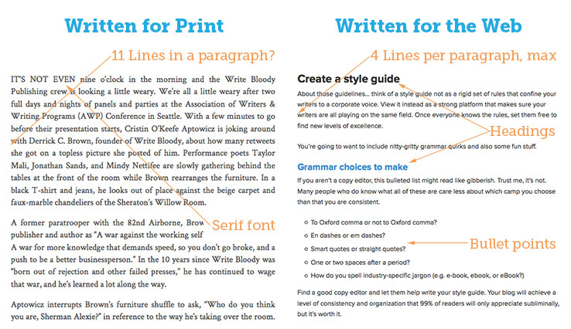

- Don't forget about SEO. Part of governance is making sure that details like metadata and title tags are taken care of. And keyword incorporation should be done by someone with a nuanced enough experience with the written word that they can both get the keywords naturally on the page and also a wide variety of synonyms—all while sounding completely natural.
- Create an editorial calendar. You're ready to start prioritizing content tasks and getting into a cadence with publishing blog posts and new social pushes. To organize all of that, you're going to need an editorial calendar. Here's an example. This doc, too, should be adapted as you find what works for your team.

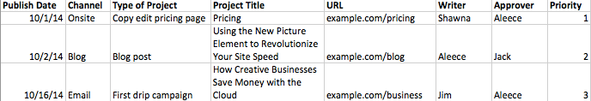

- Reconsider your CMS. That proprietary CMS you had built almost a decade ago is causing more roadblocks than any other single thing right now. Consider migrating to something like WordPress that's more user-friendly. This will radically decrease the amount of time your team spends training on and troubleshooting your existing CMS.



Technically a part of governance, workflow describes who does what and in what order. A workflow review surfaces bottlenecks and points out potential efficiencies. When you're investigating workflow, look at the entire process from ideation to post-publication evaluation. Also look beyond the content team. You might be surprised at how many people touch content (in most organizations, everyone touches content in some way).

Your stakeholder interviews are going to be essential for getting to the bottom of workflow problems and opportunities. Keep asking, and as you sketch out the content creation timeline and process, ask some more.

Content promotion and measuring success are essential components to your content strategy's longevity. Many content campaigns fail when they are not promoted, which can cast doubt on the whole strategy. And showing stakeholders how to measure the success of their content enables them to learn from content fails and also to show decision makers the value of content.

Workflow
Currently, the only people who are part of the content creation cycle are the content team, any subject matter experts (SMEs) that they identify, and the legal team. The only exception is at the ideation phase. This is a pretty common setup, in fact it's great that you're involving other departments at the ideation phase, but it could prove onerous to the content team.

Look for opportunities to leverage other team members to write some of their own content. For example, if you have a blog post that requires the technical expertise of a developer, it might make sense for a developer to write the entire post, not just the outline.

Interviewing your content team, there are a lot of ways that content can (and does) get sent back to the review process at various stages (see graphic on next page). This causes inefficiency and also frustration among the team. We recommend adding a step for major content pieces (and even complex blog posts) where the involved parties meet to talk through the idea and identify potential pitfalls.

In addition, your legal department should create a cheat sheet of things writers can and cannot say rather than doing a full review for each piece. This will free up time over all. Continue with spot checks for the time being, but you should be able to gradually phase out the legal review entirely.
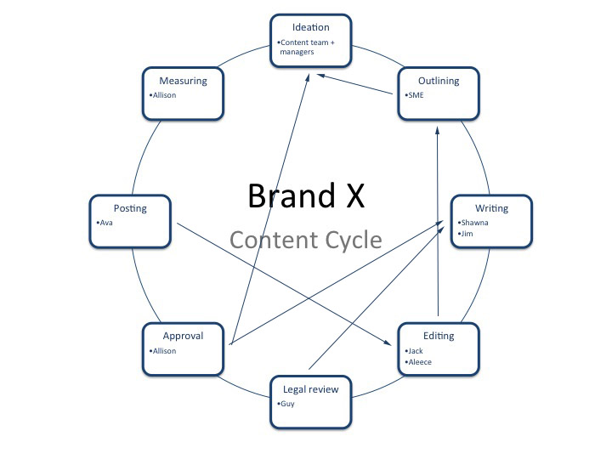

Promotion
Without proper promotion, content fails. There are lots of content assets you won't promote (much of your onsite content falls into this category), but anything that falls into the brand awareness part of the funnel needs a promotion plan behind it. Here are some other tactics to employ depending on the value of the asset (e.g. 10% content should get more promotion than 70% content):

- Social media. This is a no-brainer and while pushing out your videos and posts on your social channels is a must, don't expect huge returns from it. Do consider publicizing your content more than once, because social media (especially Twitter) has a really short shelf life.
- Paid social. To achieve the best reach in social, you'll need to leverage ads. This is neither a social nor a PPC strategy, so if you're going to set aside a large budget for ads, you might want to consult a professional. For now, suffice it to say that you should put the biggest ad investment behind the assets you estimate will be most valuable. Also consider services like Outbrain.
- PR. If you find your team is producing articles that are newsworthy, consider putting some PR behind them.
- Outreach. Likewise, if the content is something an influencer might share (and your 20% and 10% content should be), reach out to that influencer to let them know it exists.
- Syndication. Explore opportunities to take some of your blog posts and re-post them on worthy sites with a broader or different audience.

Outreach, syndication, and PR are all tactics that require more forethought. So as your team is ideating, think about which pieces might be worthy of that kind of investment and do an extra layer of investigation into who might share the content (and what their specific interests are) before putting pen to paper.

Measurement
Measuring the success of content is one of the biggest challenges marketers face. With online marketing you have the benefit of analytics, but do bounce rate and pageviews really capture what's great about content?

That said, you have to start somewhere. Here are a few metrics we use and the up (and down) sides of each:

- Bounce rate. Bounce rate often says as much about your information architecture as it does about the quality of content on a page. That said, a low bounce rate can indicate that people are interested in your content. A high bounce rate can also indicate that a lot of people were interested in that piece of content but not anything else they saw on the page. Or that the people who visited were not getting what they thought they would from the post (that it was the wrong audience).
- Pageviews. Lots of pageviews can either mean that you brought in exactly the right audience who wants to know more about your products, or they can mean that people were still looking for more information that they didn't get from the initial content.
- Time on page. A long time on page is great, if the content is lengthy. If it's not, it could indicate that the content is confusing and takes too long to process.
- Social shares. Lots of social shares are great, but don't judge a piece with poor shares too harshly. Sometimes that's more about how it was promoted than anything else. Was it shared at the right time of day? Was any budget put behind it? Should it have been on Reddit instead of Facebook. All of those kinds of issues can throw off social shares even on the best content.

As you assess these measures of content performance, keep in mind that sometimes it's good just to invest in something for its own sake because you never know what good could come from it (serendipitous marketing). This is especially true for your 10% content.

As for the rest of it, your content team should have a good handle on taking the metrics and assessing what's indicating a problem and how they can learn from each failure.



Congratulations! You've just successfully written a content strategy. You've figured out the company's starting point and, determined how content can help them fight the good fight to achieve their goals. Use this section to suggest 2-3 things the content team and/or decision makers should immediately act on. Then give them hope for a happily ever after.
This is where your story really begins. Now that you understand where your content is at, where you want to get to, and how you're going to use each channel to make all your dreams come true.

Content is a long game, so you might not see immediate rewards from your efforts, but there are a few actions you should take now to get started on the right track:

- Set up that editorial calendar. This will help you prioritize what content to create first. Once you have a roadmap, everything else feels a lot easier.
- Meet with your content team. You're ready to nail down adjustments to the workflow and to create a timeline for who gets how much turnaround on each project. It may seem daunting, but you're setting yourself up for success down the line.
- Get social. While this is not a social strategy, we'd suggest that Brand X explore which social platforms their target audience is using and start to create content that might be successful on those channels. For example, Develteam is a niche site for indie game developers. Articles like "What Traits to Look for When Building Your Dev Team" and "How Indie Game Developers Get the Most Out of a Little Cloud Space" are good examples.

Get all of your content channels headed in the right direction, and you and your new audience should be riding off into the sunset together. And if you find yourself sidetracked at all along the journey, go back to that core strategy to refocus and find your path.

